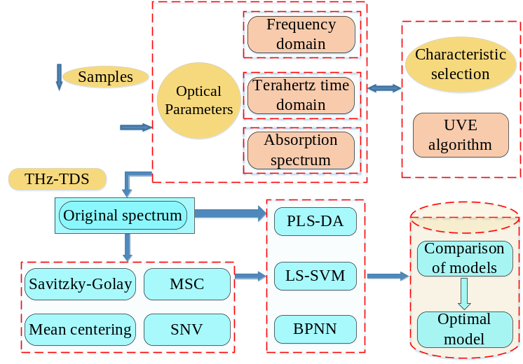
First, the time-domain spectral signals, frequency-domain spectral signals, and absorption coefficient spectral signals were collected, and the whole spectra were preprocessed by applying multiple preprocessing methods. Then, a special algorithm of uninformative variable elimination (UVE) is used to find the effective variables and remove the useless variables from the preprocessed spectrum. Finally, the PLS-DA, LS-SVM and BPNN analysis models for wheat producing areas discrimination were built based on such characteristic information, with their accuracy analyzed.

